UNIT 6

Q1) **Docker**Docker is a powerful and widely adopted open-source platform that has rapidly transformed how organizations deploy, manage, and scale software applications. It leverages containerization technology to encapsulate applications and their dependencies, ensuring consistent execution across various environments.  
Docker is a tool designed to encapsulate the entire process of creating a distributable artifact for any application. It allows for the deployment of applications at scale into virtually any environment, significantly streamlining the workflow and enhancing the responsiveness of agile software organizations. It aims to simplify the "packaging" of software.

**Key Benefits of Docker:**  
1. **Leveraging Developer Skills:** Docker packages software in a way that effectively utilizes the existing skills of developers, enabling them to build and deploy applications consistently.  
2. **Bundling and Standardization:** It bundles application software along with all its required operating system (OS) file systems and dependencies into a single, standardized image format. This ensures that an application runs the same way regardless of the underlying environment.  
3. **Hardware Abstraction:** Docker abstracts software applications from the underlying hardware. This means developers don't have to worry about hardware compatibility issues, yet the abstraction is achieved without sacrificing performance or resources.

**Process Simplification: Deployment Workflow:** Docker significantly simplifies both workflows and communication, particularly in the context of software deployment.

**1. Traditional Deployment Workflow (Without Docker):** The traditional deployment process is often iterative and complex, involving extensive back-and-forth between development and operations teams:  
 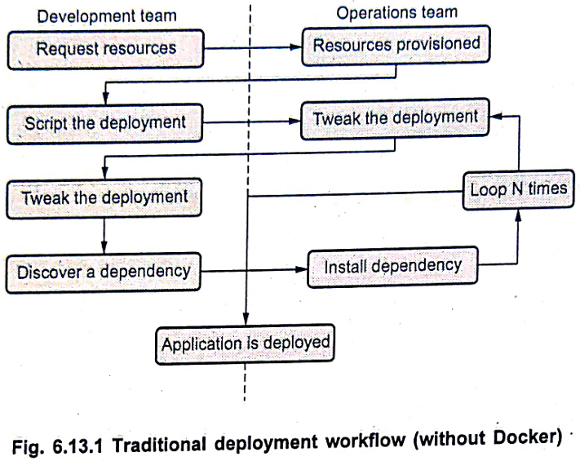  
1. Application developers request necessary resources (e.g., servers, databases) from operations engineers.  
2. Operations engineers provision these resources and hand them over to the developers.  
3. Developers then script and tool their application deployment.  
4. Operations engineers and developers frequently collaborate to tweak and refine the deployment setup, often looping through this step multiple times.  
5. During testing, developers may discover additional application dependencies.  
6. Operations engineers then work to install these newly identified requirements.  
7. Steps 5 and 6 are often repeated until all dependencies are met.  
8. Finally, the application is deployed. This process is prone to "it works on my machine" issues and environment inconsistencies.

**2. Docker Deployment Workflow:** Docker streamlines this process dramatically:  
 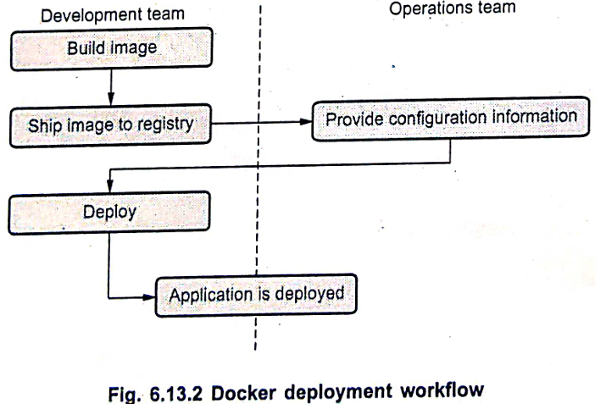  
1.**Developers build the Docker image:** The development team encapsulates the application and all its dependencies into a Docker image.  
2. **Ship image to registry:** This standardized image is then pushed to a Docker registry (a central repository for images).  
3. **Operations engineers provide configuration information:** The operations team, with minimal effort, provides environment-specific configuration details to the Docker container and provisions the necessary underlying resources (e.g., host servers).  
4. **Deploy:** Developers or operations engineers can then trigger the deployment using the pre-built image.  
5. **Application is deployed:** The application runs consistently across any environment that has Docker installed, significantly reducing "works on my machine" problems and accelerating deployment.

**Broad Support and Adoption**  
**Cloud Platform Integration:** Docker runs seamlessly on platforms like AWS Elastic Beanstalk, Google AppEngine, IBM Cloud, Microsoft Azure, and many others.  
**Industry Endorsement:** Leading technology companies, such as Google (as publicly announced by Eric Brewer), support Docker as a primary internal container format, signaling its importance for the stability and success of the containerization platform.  
**Heterogeneous Cloud Deployment:** Docker enables the deployment of applications to a heterogeneous mix of cloud providers simultaneously, offering unparalleled flexibility and avoiding vendor lock-in.  
**Operating System Compatibility:** While Docker clients can run on most operating systems (e.g., Windows, macOS via a Linux virtual machine), the core Docker server/engine relies on Linux containers and therefore primarily runs on Linux distributions. However, support has expanded beyond its traditional Ubuntu Linux origins to most modern Linux distributions and other major operating systems where possible.

**Architecture  
 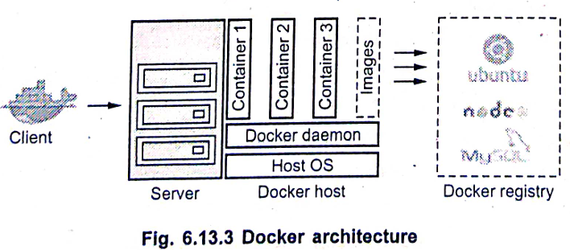**The fundamental architecture of Docker is based on a simple **client-server model**, complemented by a **registry** for image management. Underneath its user-friendly exterior, Docker heavily leverages powerful Linux kernel mechanisms, including: **IPTABLES:** For network packet filtering and Network Address Translation (NAT). **Virtual Bridging:** For creating virtual networks that allow containers to communicate. **cgroups (control groups):** For resource management, allowing Docker to limit and prioritize CPU, memory, I/O, and network bandwidth for containers. **Namespaces:** For providing process isolation, file system isolation, network isolation, etc., ensuring containers are isolated from each other and the host system. **Various Filesystem Drivers:** For managing the layers of a Docker image and container. **Key Components:  
1. Docker Server (Docker Daemon / dockerd):**A continuously running service (daemon process) that runs on a Linux host or virtual machine.It is responsible for the ongoing work of running and managing containers.It listens for API requests from the Docker client and executes them.A single daemon can run on any number of servers in the infrastructure, and a single client can address multiple daemons. **2. Docker Client:**The primary service through which Docker users communicate with Docker.It typically operates via a command-line interface (CLI).When users issue commands (e.g., docker run, docker build), the client sends these commands to the Docker daemon (dockerd), which then executes them.Clients drive all the communication, but Docker servers can also directly communicate with image registries when instructed by the client. **3. Docker Registry:**A component that stores Docker images and their associated metadata.The most well-known public registry is Docker Hub. Organizations can also run their private registries. **4. Docker Images:** These are the fundamental building blocks of Docker. An image is a read-only template that contains a set of instructions for creating a Docker container. Images are central to the Docker lifecycle. **5. Image Operations:** docker pull: Commands to retrieve (pull) required images from a configured registry directory.docker push: Commands to upload (push) images to a configured registry directory.

**Data Flow:**   
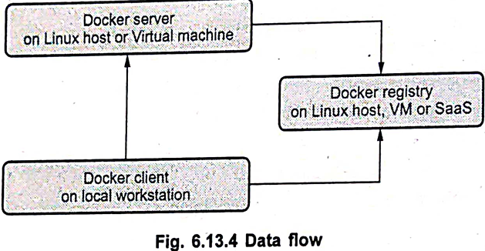  
The typical data flow involves the Docker client communicating with the Docker server (daemon). The daemon then interacts with the Docker registry (either public or private) to pull or push images, and with the host OS to run and manage containers based on those images. The Docker server is responsible for hosting containerized applications.  
---------------------------------------------------------------------------------------------------------------------------------------------------------------------------------Q2) **Container & Kubernetes  
Container Image:** A container image is a ready-to-run, standalone, executable software package that includes everything a program needs to run. This encompasses the application code, the run-times it requires, system tools, system libraries, and default values for any input settings. It serves as a lightweight, portable, and consistent environment for applications.

**Container Orchestration:** Container orchestration is concerned with the automated management of container lifecycles, particularly crucial in large, dynamic environments. Its purpose is to simplify and automate a variety of tasks involved in managing containers, such as:Deployment: Assisting in deploying the same program consistently across various environments without requiring code rewrites.Scaling: Managing the scaling up or down of containers based on demand.Networking: Configuring how containers communicate with each other and with external services.Storage: Managing data persistence for containers.Load balancing: Distributing incoming network traffic across multiple containers.

Software teams utilize container orchestration to control and automate these complex container management tasks, ensuring efficient and reliable operations.

**Kubernetes:** Kubernetes is an open-source container management and orchestration platform that automates many of the manual processes involved in deploying, managing, and scaling containerized applications. Originally developed and designed by engineers at Google, its primary responsibility is to facilitate container orchestration.

**Purpose and Functionality:**- Resource Unification: Kubernetes unifies a cluster of machines (physical or virtual) into a single, large pool of compute resources.- Application Organization: It organizes applications into logical groups of containers called Pods, which it then runs and manages using a container engine like Docker. Kubernetes ensures that your applications remain running as you request. **-** Automated Operations: It automates key operational processes such as: Deployment: Ensuring that all containers executing various workloads are scheduled to run on available nodes.Scaling: Efficiently packing containers onto nodes while adhering to deployment constraints and cluster configuration.Monitoring and Self-healing: Continuously monitoring all running containers and automatically replacing dead, unresponsive, or otherwise unhealthy containers. **-** Docker Integration: Kubernetes uses Docker to run images and manage containers. It can integrate with the Docker engine through Kubelets to coordinate the scheduling of Docker containers.  
- Higher-Level Concepts: While the Docker engine runs the container image, Kubernetes handles the higher-level concepts such as load balancing, service discovery, and network policies, reducing operational burden.  
- Modern Cloud Architecture: The combination of Docker and Kubernetes enables the development of robust and modern cloud architectures. However, it's important to remember that despite their synergy, Docker and Kubernetes are fundamentally different systems at their core: Docker is a containerization platform, while Kubernetes is an orchestration platform for those containers.

**Kubernetes Architecture**The fundamental architecture of Kubernetes follows a client-server model, where a Control Plane (Master) manages a set of Nodes (Workers).  
1. Control Plane (Master Node): The Master Node is responsible for managing the Kubernetes cluster. It is the source of all task assignments and coordinates the activity of the worker nodes. Key components of the Control Plane include:  
- API Server: The front end of the Kubernetes control plane. It exposes the Kubernetes API, which is used by external tools (like kubectl) and internal components to communicate with the cluster.  
- Scheduler: Watches for newly created Pods that have no assigned node and selects a node for them to run on based on resource requirements, policies, and affinity specifications.  
- Controller Manager: Runs various controller processes (e.g., Replication Controller, Node Controller, Endpoint Controller, Service Account Controller) that regulate the state of the cluster.  
- etcd: A consistent and highly available key-value store used by Kubernetes to store all cluster data, configuration data, state, and metadata.

2. Nodes (Worker Nodes): Nodes are the machines (physical or virtual) where containers actually run. Each node has the following components:  
Kubelet: An agent that runs on each node. It reads container manifests (e.g., Pod definitions) and assures that the defined containers have started and are running as specified. It communicates with the Control Plane.  
Kube-proxy: A network proxy that runs on each node. It maintains network rules on nodes, allowing network communication to Pods from inside or outside the cluster.  
Docker Engine: The container runtime (or another compatible runtime) that runs the containers within Pods on the node.

Key Kubernetes Objects and Concepts:  
- Pod: The smallest deployable unit in Kubernetes. A Pod represents a single instance of an application and can contain one or more containers that are deployed together on a single node. Containers within a Pod share resources like a host name, an IP address, Inter-Process Communication (IPC) namespace, and other resources.  
- Replication Controller (and ReplicaSet): Controls the number of identical copies of a Pod that should be running in different locations across the cluster, ensuring high availability and load balancing.  
- Service: An abstract way to expose an application running on a set of Pods as a network service. Services decouple the work definitions from the actual Pods, allowing service requests to be automatically sent to the correct Pods regardless of their underlying location or scaling changes.  
- Kubectl: The primary command-line configuration tool for Kubernetes, used by users to interact with the Kubernetes API server to deploy and manage applications.  
- Kubernetes Objects: These are persistent entities within the Kubernetes system that represent the state of your cluster. They are "records of intent" that Kubernetes uses to know what you want your cluster's workload to look like.  
---------------------------------------------------------------------------------------------------------------------------------------------------------------------------------  
q3) **Jungle Computing: An Integrated Distributed Computing System**  
Jungle Computing is a concept that refers to a comprehensive distributed computing system that encompasses a vast and heterogeneous collection of compute resources available to end-users. It aims to integrate and leverage virtually all forms of computational power, including:  
**Clusters:** Groups of interconnected computers working together.  
**Clouds:** Scalable and flexible computing resources delivered over the internet.  
**Grids:** Distributed systems that allow users to access and share computing resources across diverse geographical locations.  
**Desktop Grids:** Utilizing idle processing power from a network of personal computers.  
**Supercomputers:** High-performance computing machines.  
**Stand-alone Machines:** Individual computers.  
**Even Mobile Devices:** Handheld computing devices.

**Reasons for Using Jungle Computing Systems:** The concept of Jungle Computing addresses critical challenges in modern application deployment and computational demands:  
1. **Meeting High Compute Power Demands:** Many contemporary applications require significantly more computational power than what is available in any single system or environment an end-user typically has access to. Jungle Computing pools these resources to meet such demands.  
2. **Addressing Diverse Computational Requirements:** Different parts or modules of a complex application may have varying and specialized computational requirements. No single computing system or paradigm can optimally fulfill all these diverse needs. Jungle Computing allows for the dynamic allocation of tasks to the most suitable resource type within its heterogeneous ecosystem.

**High-Level View and Resource Perception:** From a high-level perspective, all the diverse resources within a Jungle Computing System are considered to be somewhat equivalent in terms of their fundamental capabilities, each offering a certain amount of processing power, memory, and storage. For end-users, the underlying complexity is abstracted away; they simply perceive these aggregated resources as a unified "compute resource" available to run their applications, without needing to manage the specifics of each component.

**Context with Other Distributed Computing Paradigms:** Jungle Computing is an evolution in the landscape of distributed computing. It builds upon the visionary aims of earlier paradigms:  
**Grid Computing:** Introduced over a decade ago, grid computing's primary goal was to provide efficient and transparent "socket computing" over a distributed set of resources.  
**Other Paradigms:** This was followed by the introduction of other distributed computing paradigms like peer-to-peer computing, volunteer computing, and more recently, cloud computing.

All these paradigms share the common objective of providing end-users with seamless access to distributed resources with as little effort as possible. The emergence of these new paradigms has led to an increasingly diverse collection of resources available to researchers, including stand-alone machines, cluster systems, grids, clouds, and desktop grids.

**Challenges and Complexity:** Despite the promise of vast computational power, Jungle Computing also highlights significant challenges:  
**Programming and Usage Complexity:** The increasing prevalence of multi-core processors and specialized many-core "add-ons" in clusters, grids, and clouds makes programming and efficiently utilizing these systems increasingly difficult.  
**Heterogeneity and Mapping Problems:** Beyond multi-core programming, the growing heterogeneity of the underlying hardware further complicates the efficient mapping of computational problems onto the "bare metal" resources. This requires sophisticated resource management and scheduling.  
**Awareness of Parallelism:** More than ever, programmers must possess a deep understanding and awareness of the potential for parallelism at all levels of granularity within their applications to effectively leverage the power of such diverse and distributed systems.  
---------------------------------------------------------------------------------------------------------------------------------------------------------------------------------  
Q4) **Multimedia Cloud**  
Multimedia Cloud refers to the innovative application of cloud computing principles for the processing, accessing, storing, and delivery of multimedia content—such as audio, video, and images—over the internet. With the advent of cloud computing, users can now efficiently store and access multimedia content of any type and size in the cloud, eliminating the need for extensive local storage or complex hardware.

**Key Functionalities and Capabilities:**  
1. **Comprehensive Content Management:** Multimedia clouds go beyond simple storage. They are designed to process media content, which is crucial given the often computationally intensive nature of processing multimedia data. This leverages the powerful CPU and GPU resources available within the cloud infrastructure.  
2. **Flexible Access and Delivery:** After processing, the data can be easily accessed and received by various client devices (computers, tablets, smartphones, cars) without requiring complex local hardware installations. This enables users to view or stream multimedia content anywhere in the world, at any time.  
3. **Advanced Streaming Capabilities:** Multimedia content can be streamed directly from the cloud to clients using standard multimedia signaling protocols like TCP/IP, UDP, RTP, and HTTP. The cloud system also handles tasks such as loading or buffering media data, coding, mixing, rating, and rendering, ensuring a smooth streaming experience.  
4. **Content Optimization:** The cloud performs essential optimizations like profiling, packetizing, and tokenizing of media contents based on the streaming protocols used, ensuring efficient delivery to the client system.  
5. **Integrated Content Management Systems:** Many major cloud providers, such as Amazon EC2, Google Music (now YouTube Music), Dropbox, and Microsoft OneDrive (formerly SkyDrive), offer robust content management systems integrated within their cloud networks, enabling seamless organization and access to multimedia files.

**Architecture and Components:**   
 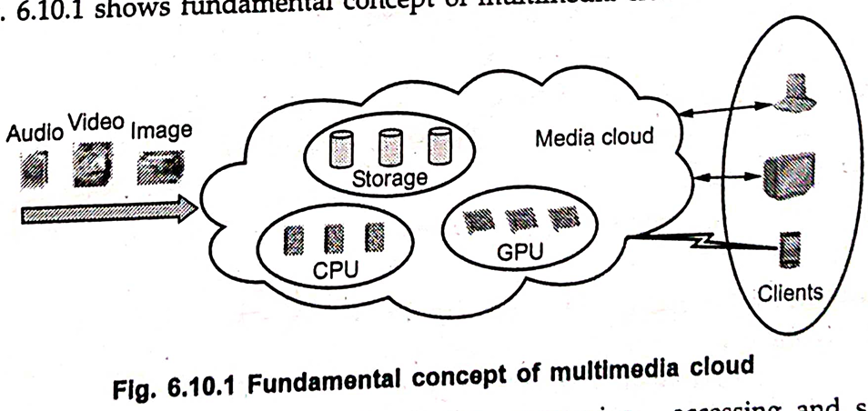  
The concept of Multimedia Cloud involves a sophisticated architecture that can be viewed in two layers: the underlying "Media Cloud" infrastructure and the "Cloud Media" services built upon it.  
1. **Media Cloud (Core Infrastructure):** This represents the foundational cloud infrastructure that hosts the multimedia services. Its core components include:  
 **Storage:** Massive hard disk arrays or other storage solutions for storing multimedia files.  
 **CPU (Central Processing Unit):** General-purpose processors for managing operations and some data processing.  
 **GPU (Graphics Processing Unit):** Specialized processors essential for accelerated multimedia processing tasks like video encoding/decoding, rendering, and image manipulation, where high computational power is required.  
**Resource Allocator:** Manages and distributes computational resources (CPU, GPU, storage) to meet the demands of various multimedia tasks.  
**Load Balancer:** Distributes incoming network traffic and processing requests across multiple servers or resources within the cloud to ensure optimal performance and prevent overload.  
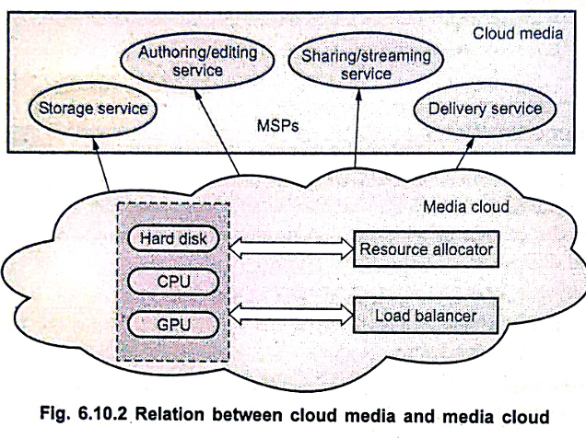

**2. Cloud Media (Services Layer):** Built on top of the Media Cloud infrastructure, this layer provides the specific services for managing and delivering multimedia content. These services are often offered by Managed Service Providers (MSPs) and include:  
**Authoring/Editing Service:** Cloud-based tools that allow users to create, modify, and enhance multimedia content collaboratively.  
**Sharing/Streaming Service:** Facilitates the sharing of multimedia files and enables their real-time streaming to client devices.  
**Delivery Service:** Manages the efficient and reliable delivery of multimedia content to various client platforms across different networks.  
**Storage Service:** Provides the interface and management for storing multimedia content in the cloud.

**Benefits and Impact:** Cloud media technology offers significant benefits to both service providers and end-users:  
**Increased Efficiency:** Service providers benefit from faster implementation times, efficient data storage capacity, and reduced computational and operational costs.  
**Global Accessibility:** Users can access and consume multimedia content anywhere, anytime, on a wide range of devices.  
**Enhanced Processing Capabilities:** It has made a striking impact on various multimedia content processing tasks, including:   
 **Editing:** Enabling complex video and audio editing remotely.  
 **Storing:** Providing scalable and secure storage solutions.  
 **Encrypting and Decrypting:** Ensuring the security and privacy of multimedia content  
 **Streaming:** Revolutionizing how video and audio content is consumed.  
 **Compressing:** Efficiently compressing large multimedia files for storage and transmission.  
---------------------------------------------------------------------------------------------------------------------------------------------------------------------------------  
q5) **IPTV: The Future of Television Driven by Cloud Computing**  
IPTV (Internet Protocol Television) represents a significant paradigm shift in television content delivery, moving away from traditional broadcast and cable methods towards internet-based distribution. Driven by evolving consumer behaviors and the capabilities of cloud computing, IPTV allows users to watch video content on a wide variety of connected devices, offering unprecedented flexibility in terms of time, location, and device choice. The rise of Over-The-Top (OTT) providers like Netflix exemplifies this trend, offering direct-to-consumer services characterized by low prices, advanced user interfaces, and seamless access to multi-screen video.

**Impact on Traditional TV and the Shift to Cloud-based Models:** The transition to IPTV brings profound changes to the traditional television ecosystem:  
1. **Evolving Consumer Habits:** Subscribers increasingly desire to watch content at their chosen time, location, and on their preferred device (smartphones, tablets, smart TVs, computers). This shift in consumption patterns puts immense pressure on traditional content distribution models and significantly increases distribution costs.  
2. **Challenges for Pay TV Providers:** Traditional Pay TV providers are particularly susceptible to these trends. They are compelled to adapt their legacy TV delivery architectures to offer innovative services that can attract and retain customers who are increasingly opting for flexible, on-demand viewing experiences.  
3. **Demise of Traditional Set-Top Boxes (STBs):** The functions of the traditional Set-Top Box are gradually disappearing. Their capabilities are being absorbed into the network itself and by the connected devices consumers already own (e.g., smart TVs, streaming sticks). This eliminates the significant cost and complexity associated with managing home-based STB hardware.  
4. **Shift to Unicast Traffic:** In the IPTV model, traffic fundamentally shifts from broadcast and multicast methods (where a single stream reaches many users simultaneously) to unicast streams (where each user receives a unique stream). This change, combined with device format fragmentation, time-shifting viewing habits, and personalized content delivery, erodes the efficiency benefits of traditional broadcast and multicast approaches.  
5. **Cloud as the Delivery Platform:** Ultimately, every end-user will be served with a unique, personalized stream, with services increasingly deployed directly in the cloud. Dedicated video platforms, previously run on specialized hardware, are migrating to cloud-based services, which not only reduces operational costs but also accelerates the time-to-market for new content and features.  
6. **Architectural Modernization for Operators:** To embrace this cloud-centric model, operators are moving away from vertically integrated, proprietary middleware stacks. Instead, they are adopting more open architectures that allow for the integration of "best-of-breed" components from various providers, fostering innovation and flexibility.

**Role and Benefits of Cloud Computing in IPTV:** Cloud computing is the enabling force behind the evolution of IPTV, offering numerous advantages:  
1. **Software-Based Service Delivery:** A key benefit of cloud-based services is their software-centric nature. This means that operations do not require a physical presence or dedicated hardware in numerous locations. Consequently, real estate, infrastructure, and manpower costs are dramatically reduced.  
2. **Cloud DVR Technology:** Cloud DVR (Digital Video Recorder) technology is a prime example of cloud's impact, making all TV content available on demand, on any device, and from any location. This offers unparalleled convenience to the consumer.  
3. **Flexible Market Entry and Testing:** Cloud-based technology enables unprecedented flexibility for businesses. For instance, a Bollywood film channel interested in testing the US market can launch its services via cloud technology, potentially using leased satellite capacity for a few months. This allows market validation without the prohibitive upfront costs and long-term commitments of traditional infrastructure.  
4. **Scalability and Reach:** Cloud platforms provide the inherent scalability required to serve millions of users concurrently with personalized streams, adapting to fluctuating demand without significant over-provisioning.  
5. **Market Adoption:** Products like ActiveVideo's CloudTV, which leverages cloud computing to deliver interactive TV experiences, are already widely available, demonstrating the broad market adoption and effectiveness of cloud-based IPTV solutions on millions of devices.  
-----------------------------------------------------------------------------------------------------------------------------------**----------------------------------------------  
q6) CometCloud: An Autonomic Computing Engine for Heterogeneous Cloud and Grid Environments**  
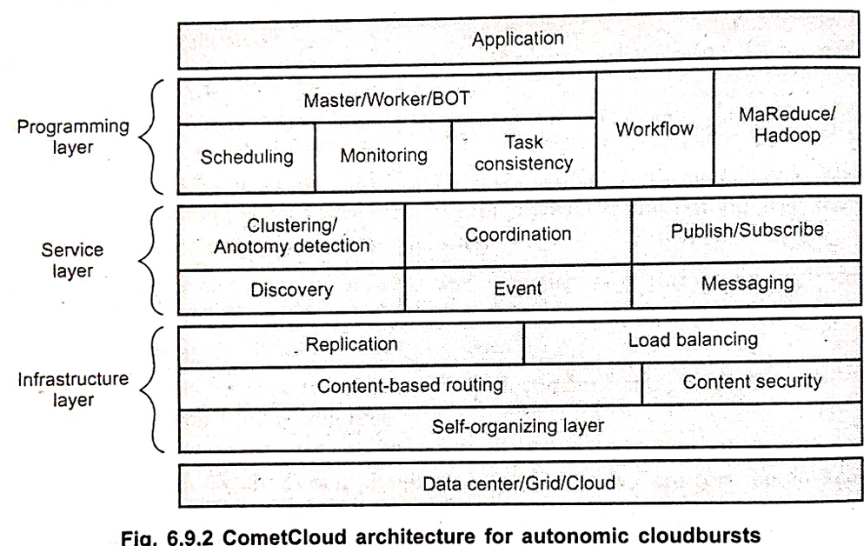CometCloud is a sophisticated distributed computing system designed as an **autonomic computing engine** specifically for cloud and grid environments. It is built upon a **decentralized coordination substrate**, enabling seamless support for highly heterogeneous and dynamic infrastructures, including public and private clouds, as well as facilitating "cloudbursts" (the overflow of compute tasks from private to public clouds during peak demand).

CometCloud's architecture is structured into three distinct but interconnected layers:  
**1. Programming Layer**: The programming layer provides the fundamental framework for application development and management within the CometCloud environment. It supports a range of distributed computing paradigms to orchestrate tasks:  
**Master/Worker/BOT (Bag of Tasks):** This paradigm involves "Masters" generating tasks that are then consumed and processed by "Workers" (or computational nodes).  
**Key Functions:**   
**Scheduling:** Managing the allocation of tasks to available resources.  
**Monitoring:** Tracking the progress and status of tasks and resources.  
**Task Consistency:** Ensuring that tasks are executed reliably and produce consistent results.  
**Workflow:** Orchestrating sequences of tasks to form complex application workflows.  
**MapReduce/Hadoop:** Integration with popular frameworks for processing large datasets.

**2. Service Layer:** The service layer offers a diverse set of services designed to support **autonomics** at both the programming and application levels. This layer enables applications to dynamically adapt and manage themselves without human intervention: **Clustering/Anomaly Detection:** Services for grouping resources and identifying unusual patterns or deviations in system behavior. **Coordination:** Facilitating communication and synchronization among distributed components. **Publish/Subscribe & Messaging:** Provides asynchronous messaging and eventing services, allowing different parts of an application to communicate efficiently and react to events. **Discovery:** Services that help components find and interact with each other within the distributed environment. **Event:** Handling and processing events that occur within the system, triggering appropriate actions. **Flexible Application Usage:** An application can dynamically switch between different execution "spaces" (e.g., different cloud providers or resource pools) at runtime and can simultaneously utilize multiple spaces for parallel processing.

**3. Infrastructure Layer:** The infrastructure layer forms the decentralized coordination substrate upon which CometCloud is built. It leverages advanced peer-to-peer technologies for robust and scalable operations: **Core Technologies:** It utilizes the **Chord self-organizing overlay network** for distributed hash table functionality, and the **Squid information discovery and content-based routing substrate**, which is built on top of Chord. **Routing Engine:** The routing engine supports flexible **content-based routing** and complex querying capabilities. This means data and requests can be routed based on their content, allowing for sophisticated searches using partial keywords, wildcards, or ranges. **Key Functions:**  **Replication:** Maintaining multiple copies of data or services across the network for fault tolerance and availability. **Load Balancing:** Distributing workloads evenly across available resources to optimize performance and resource utilization. **Content-based Routing:** Directing data packets based on their content or attributes rather than just their destination address. **Content Security:** Implementing measures to protect the integrity and confidentiality of data. **Self-organizing Layer:** The network can dynamically adapt to changes, such as nodes joining or leaving, and can handle node failures gracefully without disruption. **Data Center/Grid/Cloud Integration:** This layer acts as the bridge to the underlying physical data centers, grids, and various cloud environments, providing the unified resource pool for the upper layers.  
-----------------------------------------------------------------------------------------------------------------------------------**----------------------------------------------  
Q7)** **Mobile Cloud Computing (MCC)**At its simplest, Mobile Cloud Computing refers to an infrastructure where both the data storage and data processing happen outside of the mobile device, within the computational cloud. Mobile cloud applications are designed to move the computing power and data storage away from mobile phones and into powerful and centralized computing platforms in the cloud. This allows for a broader range of mobile subscribers to access sophisticated applications and mobile computing services, transcending the limitations of their smartphones. Mobile devices then access these cloud-hosted applications and data over a wireless connection, often utilizing a thin native client.

MCC essentially allows mobile users to leverage infrastructure, platforms, and software provided by cloud providers at a low cost and in an elastic, on-demand fashion. All resource-intensive computing, which typically demands significant CPU speed, memory capacity, and storage, can be performed in the cloud, obviating the need for powerful device configurations.

**Architecture of Mobile Cloud Computing:** The architecture of Mobile Cloud Computing combines mobile network infrastructure with cloud computing resources to provide optimal services for mobile clients. The general flow is as follows: **A diagram of a cloud service
1. Mobile Network Layer:**Mobile devices (e.g., smartphones, tablets) connect to mobile networks through Base Stations (BTS).These base stations establish and control the air interface and functional interfaces between the mobile networks and mobile devices.Mobile users send service requests (e.g., via a web browser or desktop application on their mobile device).   These requests and information are transmitted to central processors that are connected to servers providing mobile network services (which may include databases and High Availability (HA) setups).Services like Authentication, Authorization, and Accounting (AAA) can be provided based on a Home Agent (HA) and subscriber data stored in databases within the mobile network. **2. Internet Service Providers (ISPs) Layer:**The subscriber's requests from the mobile network's central processors are then delivered to the cloud through the Internet via Internet Service Providers (ISPs). **3. Cloud Computing Layer:**Within the cloud, Cloud Controllers process the incoming requests.  
These controllers manage the allocation of resources in various Data Centers (e.g., Cloud A, Cloud B), which house vast computing power, storage, and application servers.  
The cloud processes the requests and performs the necessary data storage and computation.  
Finally, the results or the application itself, running on a remote server, are sent back to the mobile client, which displays them on the mobile device.

**Advantages and Disadvantages of Mobile Cloud Computing**  
**Advantages:**  
1. Saves Battery Power: By offloading computation and data storage to the cloud, mobile devices expend less processing power locally, significantly extending their battery life.  
2. Makes Execution Faster: Resource-intensive tasks that would run slowly or not at all on a mobile device can be executed rapidly on the powerful, centralized cloud servers.  
3. Improves Data Storage Capacity and Processing Power: Mobile devices are no longer limited by their internal storage or processing capabilities, gaining access to virtually unlimited cloud storage and scalable computing power.  
**Disadvantages:**  
1. Must Send Program States (Data) to the Cloud Server: For tasks to be processed in the cloud, the mobile device must transmit the necessary program states or data to the cloud server, which can consume bandwidth and introduce overhead.  
2. Network Latency Can Lead to Execution Delay: The reliance on a wireless connection and the internet means that network latency can become a significant factor. High latency or poor network conditions can lead to delays in execution and impact the responsiveness of applications, negating some of the speed benefits of cloud processing.  
-----------------------------------------------------------------------------------------------------------------------------------**----------------------------------------------  
Q8) Location-Aware Applications**Location is a fundamental and exciting aspect of the new world of mobile web-enabled services. The utility and popularity of many modern mobile applications and services are largely determined by a crucial factor: the user's exact geographical position at the moment they are using the service.A location-based service (LBS) is defined by three key characteristics:  
1. User Location Determination: The user must be able to determine their current geographical location.  
2. Spatially Related Information: The information or service provided must be directly and spatially related to the user's determined location.  
3. Dynamic Interaction: The service offers the user dynamic or two-way interaction with the location information or content, making it interactive and responsive to their position.

**Components of Location-Based Services:** For a location-based service to function effectively, it relies on several core components:  
1. Mobile Device: The primary device used by the end-user to access the service and provide location data (e.g., smartphone, tablet).  
2. Content Provider: The entity that supplies the spatially relevant information or services based on location (e.g., a mapping service, a local business directory).  
3. Communication Network: The infrastructure (e.g., cellular networks, Wi-Fi, internet) that enables communication between the mobile device, the content provider, and the positioning components.  
4. Positioning Component: The technology or system responsible for determining the user's geographical position (e.g., GPS receiver, cellular tower triangulation).

**How Position is Detected: Location-aware applications determine geographical position mainly through two categories of technologies:**Satellite Technologies: Such as GPS (Global Positioning System), which uses signals from orbiting satellites to pinpoint a device's location.Mobile Location Technologies: These leverage existing infrastructure within cellular networks and mobile devices, often involving techniques like cell tower triangulation, Wi-Fi positioning, or Bluetooth beacons, especially useful indoors or in urban canyons where GPS signals may be weak.

**Examples of Location-Aware Applications**: Location-aware applications are widely used across various sectors, leveraging the geographical position of mobile workers or assets to execute tasks. Examples include:  
Fleet Management Applications: Used for tracking vehicles, optimizing routes, and monitoring vehicle status.  
Mapping, Navigation, and Routing Functionalities: Providing directions, traffic updates, and optimal routes based on current location.  
Government Inspections: Enabling inspectors to log location-specific data during fieldwork.  
Integration with Geographic Information System (GIS) Applications: Combining real-time location data with rich geographical datasets for analysis and visualization.

**Advantages of Location-Aware Applications: Location-aware applications offer several significant advantages:**Affordable Implementation: They present an affordable implementation solution as they can often leverage the existing capabilities of mobile devices without requiring the purchase or installation of extra, specialized hardware.Indoor and GPS-Denied Awareness: These applications can provide location awareness even within buildings or areas where traditional GPS signals cannot be used, thanks to alternative mobile location technologies.Customized Map Building: They facilitate the creation and use of customized maps that can display location-specific information relevant to the user's context or application needs.  
-----------------------------------------------------------------------------------------------------------------------------------**----------------------------------------------  
Q9)** **Automatic Cloud Engine (Autonomic Cloud Management)**An Automatic Cloud Engine, rooted in the concept of **autonomic computing**, refers to the ability of a distributed system to manage its resources with minimal or no human intervention. This involves the system intelligently adapting to its environment and responding to user requests in a way that is often transparent to the user. Autonomic monitoring, a key aspect of such systems, is typically implemented at specific layers of the cloud computing architecture to ensure efficient and secure operations.

**High-Level Architecture for Autonomic Cloud Management:** The system architecture for autonomic cloud management, particularly for Software as a Service (SaaS) applications on clouds, is typically layered, reflecting the common cloud service models:  
1. SaaS Layer (Software as a Service):**This is the topmost layer, directly accessible by end-users or brokers.It comprises **SaaS application portals**, which host and provide the SaaS applications using a Web Service-enabled portal system (e.g., Healthcare applications, Spatial-temporal analytics platforms).Users or brokers submit service requests from anywhere in the world to these SaaS applications. **2. SaaS/PaaS Integration Layer:**This layer acts as the bridge between the SaaS applications and the underlying Platform as a Service (PaaS) layer. It facilitates the communication and seamless integration of services and data. **3. PaaS Layer (Platform as a Service - Autonomic Management System):**This is the core of the autonomic cloud engine, serving as a platform-as-a-service.Its architecture integrates various autonomic management components designed to enforce security and energy efficiency.The PaaS layer plays a crucial role in coordinating cloud resources according to the SaaS application requirements, ultimately ensuring the desired User QoS (Quality of Service).Key components and services within this layer include:  **Autonomic Management System:** Incorporates vital services like **Security and Attack Detection**, **Application Scheduling**, and **Dynamic Resource Provisioning**. **Security and Attack Detection:** This component performs checks on incoming requests to evaluate their legitimacy. It's crucial for preventing the scaling-up of resources in response to requests intended to cause Denial of Service (DoS) attacks or other cyber threats. It must be able to distinguish between authorized access and malicious attacks, deciding whether to drop suspicious requests or avoid excessive resource provision. **Application Scheduler:** This component is responsible for assigning each task within an application to appropriate resources for execution. Its decisions are based on user QoS parameters and the overall cost for the service provider.  
 **Energy-Efficient Scheduler:** A specialized objective within the application scheduling process is energy utilization. This scheduler aims to schedule applications in a way that minimizes their total energy consumption without compromising Service Level Agreements (SLAs) and cost efficiency  
**Dynamic Resource Provisioning Algorithms:** These algorithms implement the logic for provisioning and managing virtualized resources across both private and public cloud environments. They operate based on the resource requirements dictated by the application scheduler. **Workflow:** Manages and orchestrates the sequence of operations and tasks within the PaaS framework. **PaaS Framework:** Provides the foundational environment and tools for the platform-as-a-service offerings. **Integration:** Handles the connection and communication with other components and layers. **4. PaaS/IaaS Integration Layer:**This layer connects the PaaS layer with the underlying Infrastructure as a Service (IaaS) layer, translating the resource requirements from the PaaS into actionable commands for the IaaS. **5. IaaS Layer (Infrastructure as a Service):**This is the bottommost layer, providing the distributed computing resources.It comprises both **Private Clouds** and **Public Clouds** (e.g., Datacenter A, Datacenter B), which offer the raw computing power, storage, and networking infrastructure upon which the higher layers operate.  
-----------------------------------------------------------------------------------------------------------------------------------**----------------------------------------------  
Q10) Energy Aware Cloud Computing**Energy Aware Cloud Computing focuses on optimizing the energy consumption within cloud infrastructures, particularly data centers, which are the backbone of cloud services.  
**Why is it Important?**  
**Growing Energy Consumption:** The explosive growth of cloud infrastructure has drastically increased the energy consumption of data centers. This escalating demand has made energy consumption a critical concern, impacting both the environment and the operational costs of cloud service providers.  
**High Costs and Environmental Impact**: Data centers are not only expensive to maintain but also environmentally unfriendly due to their significant energy requirements, contributing substantially to greenhouse gas (GHG) emissions. For instance, Amazon.com's estimate shows that energy-related costs can account for up to 42% of a data center's total budget over a 15-year amortization period  
**Governmental Pressure:** There is increasing pressure from governments worldwide to reduce carbon footprints, which has a significant impact on climate change.  
**Shift in Optimization Focus:** As energy costs rise and availability dwindles, there's a crucial need to shift focus from merely optimizing data center resource management for pure performance to optimizing for energy efficiency while consistently maintaining high service level performance and reliability.

**Strategies in Energy Aware Cloud Computing   
(Green Cloud):** A Green Cloud computing model aims to achieve not only efficient processing and utilization of computing infrastructure but also to minimize energy consumption.   
Key strategies and technologies include:  
Green Storage: This involves using "clean energy" storage methods and products to reduce a data center's carbon footprint and costs. Approaches for green storage include:  
Tape Storage: A popular and energy-efficient method, as tape has no moving parts, consumes less energy, and offers a longer shelf-life compared to other storage technologies.  
Virtualized Servers: Hosting multiple virtualized servers on a single physical server significantly improves efficiency and reduces the need for expensive hardware, thereby saving energy.  
Solid-State Drives (SSDs): Although often more expensive, SSDs are energy-efficient and faster alternatives to traditional mechanical hard disk drives.  
Massive Array of Idle Disks (MAID): This system architecture spins up only active drives and keeps inactive drives idle, cutting down on energy use and prolonging the drives' shelf-life.  
Leveraging Renewable Energy Sources: Companies like Google, Microsoft, and Yahoo are building large data centers in areas with access to cheap hydroelectric power (e.g., near the Columbia River in the USA) to exploit renewable energy sources for their operations.

**Green Computing:** Green Computing (also known as Green IT) refers to the study and practice of designing, manufacturing, using, and disposing of computers, servers, and associated subsystems (like monitors, printers, storage devices, and networking/communication systems) in an environmentally responsible and eco-friendly way, efficiently and effectively, with minimal or no impact on the environment, while maintaining overall computing performance.    **Why is it Important?  
Environmental Burden:** Computers and IT infrastructure consume significant amounts of electricity, placing a heavy burden on global electric grids and contributing substantially to greenhouse gas (GHG) emissions  
**Electronic Waste:** Electronic devices are toxic to the environment due to the materials used in their manufacturing, their limited battery life, and rapid technological obsolescence, leading to a growing problem of "electronic waste" (e-waste). **Responsible Practice:** Green computing represents a responsible way to address the issue of global warming and helps business leaders contribute positively to environmental stewardship, protect the environment, and reduce both energy and paper costs. **Complementary Approaches to Green Computing:** To promote green computing concepts at all possible levels, four complementary approaches are employed:  
Green Use: Minimizing the electricity consumption of computers and their peripheral devices, and using them in an eco-friendly manner.     
Green Disposal: Re-purposing existing computers, appropriately disposing of, or recycling unwanted electronic equipment to prevent environmental harm.     
Green Design: Designing energy-efficient computers, servers, printers, projectors, and other digital devices from the ground up.  
Green Manufacturing: Minimizing waste during the manufacturing process of computers and other subsystems to reduce their environmental impact.

**Benefits of Green IT: Adopting Green IT practices yields numerous benefits:**Reduced Power and Resource Consumption: Directly leads to lower energy bills and conservation of natural resources.Waste Management and Recycling: Green technology facilitates better management and recycling of waste materials, particularly e-waste.Reduced Environmental Impact and Carbon Footprint: Lowers GHG emissions and minimizes the overall negative impact on the environment.Improved Operational Efficiency: Often, energy-efficient systems are also more streamlined and cost-effective to operate in the long run.  
-----------------------------------------------------------------------------------------------------------------------------------**----------------------------------------------  
Q11)** **Key Issues Related to Energy Efficiency in Cloud Computing  
1. High Energy Consumption in Data Centers**

* Cloud data centers house thousands of servers running 24/7.
* Massive electricity is required for **computing**, **storage**, and **cooling**.
* Inefficient resource utilization leads to **wastage of power**.

**2. Idle Resource Usage**

* Servers often run at low utilization levels but still consume **60–70% of peak power**.
* Poor **workload management** leads to underused servers still consuming energy.

**3. Cooling Systems and Thermal Management**

* Nearly 40–50% of data center energy is used just for cooling.
* Traditional cooling methods are inefficient and increase carbon footprint.
* Lack of **smart thermal management** causes energy wastage.

**4. Lack of Green Policies and Energy-Aware Scheduling**

* Energy-inefficient software and **non-optimized scheduling algorithms** increase load.
* Lack of **energy-aware resource allocation** causes over-provisioning and higher energy use.

**5. Virtualization Overhead**

* Virtualization helps in better resource utilization, but if not optimized, it introduces **performance overhead**.
* Improper VM placement or migration leads to **unnecessary energy usage**.

**6. Geographical Distribution and Network Costs**

* Cloud infrastructure spread globally involves energy-consuming **data transfer across regions**.
* High **network latency** and **bandwidth usage** increase energy cost.